Core Highways Release Notes v4.4.0.0

Table of Contents
1 Document Control 3
1.1 Author 3
1.2 Document Summary 3
1.3 Document History 3
1.4 Reference documents 3
1.5 Distribution 3
1.6 Quality Assurance 3
2 Introduction 4
3 Fixes, Enhancements and Changes at 4.4.0.0 5
4 Known Problems at 4.4.0.0 12
4.1 Merge Query issues known to remain at release 4.4.0.0 12
4.2 Other issues known to remain at release 4.4.0.0 16
4.3 ECDM Logs, Ticket numbers and test failures. 18

- Document Control
- Author
Rob Coupe Technical Architect & Development Manager
Ade Edwards Senior Developer
Chris Strettle Developer
- Document Summary
This document provides a description of the changes in this release and information about how these changes may impact on an Exor installation.
- Document History

Document History
Revision | Date | By | Description
1.0 | 14th April 2011 | Rob Coupe | First Draft
1.1 | 15th April 2011 | Rob Coupe | Addition of known bugs
1.2 | 5th May 2011 | Chris Strettle | Change to task 0110504 notes.
1.3 | 11th May 2011 | Rob Coupe | More known bugs
- Reference documents
None

- Distribution
Exor Customers, Partners and Colleagues

- Quality Assurance
Document Details
File | Prepared By
0000.doc | Rob Coupe
Document Name | Reviewed By
Core Release Notes v4.4.0.0
Version | Approved for issue by
1.0
Date of Issue
14th April 2011

- Introduction
This document highlights the key changes to the exor Core Highways database following the release of Core Highways v4.4.0.0. It is specifically targeted at users and system administrators of the exor systems. Changes in the core database functionality have the potential to have wide impact across all exor applications and it is important that these changes are understood. However, many of the functions of exor Core Highways are extremely technical in nature and this document is aimed at those with some degree of technical knowledge and not necessarily at end users.

It is not intended to be a full system description but a guide to indicate what changes have been made, why they have been made and the potential failings if this upgrade is not applied.

This release is available as an upgrade from release 4.3.1.0 and 4.3.0.0 exor Core Highways.

After reading through this document, should you have any need for training or consultancy then please contact your exor/Bentley account manager. If these changes are considered important for your current release and this is incompatible with this patch release then please contact support.

This release is, in the main a bug-fix release and a technology change in that it has been adapted to be used on Oracle 11.2.0.2 RDBMS and with the latest iterations of Esri 9.3.1 compliant products.

The issues that have been attended to are a result of internal testing, customer raised issues and internally driven enhancements and improvements. Where the change has been made as a result of an existing ECDM log raised by a customer, the table of fixes makes reference to the ECDM log. Since the last release, customer support has moved to using a SAP system which fits with the Bentley support methodology. In these case, the ECDM log number has been replaced with a SR help ticket number. These are much larger numbers, generally prefixed by 8000.

The 4.4.0.0 release is to be shipped with a new version of the MapViewer tool. This version has some important performance and reliability improvements and has an improved interface in relation to tool button sizes and legends. Although recent releases of Spatial Manager will remain compatible with the release 4.4.0.0, it too has many fixes and improvements. It is important that the version on the release is used as important fixes have been made. At the time of going to press the build number of Spatial Manager remains unknown. The last build number of 3.25 has known bugs which it is hoped will be rectified and tested prior to the release with 4.4.0.0 of Core Highways. This will be based on and tested on ArcView version 9.3.1 Service pack 2 using ArcSDE 9.3.1 Service Pack 2 with the general update patch applied.

For versions of middle-tier products please check the upgrade guides as again, no build numbers or versions are available at the time of writing.

- Fixes, Enhancements and Changes at 4.4.0.0
The following are a list of internal task identifiers with associated ECDM fault logs/Bentley help ticket numbers (where appropriate) that have led to changes in the 4.4.0.0 release.

Internal  Task ID | Issue | Support  Log(s)
0107857 | A number of changes have been made to allow a number of forms to show long element descriptions. This includes NM0105, NM0122, NM0510, NM0560, NM0590, NM1401, NM1861, NM7051 as well as others that reference these forms. This is ongoing work and a handful of modules such as reports still exhibit this problem. | 721136  724062
0108176 | NM0115 Groups of Groups module - Admin Unit and Network Type LOV validation improved, along with restricting Description field to upper case to prevent mismatches on string searches.
0108669 | HIG1832 Users module - The default for the user tablespace, temp tablespace and user profile are set to valid defaults. Previously they were set to product options regardless of what they we set too. Now the product option value will only be used if it is valid if it is not valid then a valid value will be set as the default instead.
0108684 | Asset modules - Locating an asset on a date before the network was open now being handled with a sensible error message.
0109403 | Introduced functionality to allow the Process Framework to be switched off.  A new Form HIG2550 Process Framework Administration has been introduced to show the Status of the Process Framework and to allow it to be shut down/started.  Additional pre-upgrade/pre-install checks have been added to product upgrade and install scripts to shut down the framework and to ensure that there are no running processes.
0109627 | Previously there would be an incorrect error. Merge, Replace and Reclassify would give an error saying the date was out of range when the start date of the elements entered was in the year 2000. This issue has now been fixed so the elements that started in the year 2000 do not result in an error.  An impact analysis has been carried out and the issue only occurred in these three forms.
0110082 | Process Types module - The Process Types form Area Polled Locations tab to show the Out Directory. This will give the user more important information regarding the locations.
0110245 | Create group from Extent - The extended LOV now returns the correct selected fields all the time. | 728261
0110247 | NM0560 Assets on a Route module - The Assets on a route form no longer asks the user to commit when they try and exit the form after entering search criteria. | 728122
0110249 | HIG1832 Users module - Under certain conditions it was possible to lock the form up when entering invalid role information.
0110251 | Changes made to the NM0002 & NM0004 forms.  The views created in these forms no longer need to be based on linear network/group types.
0110256 | Changes made to the NM0002 & NM0004 forms.  The ability to register network as a FT is no longer restricted to datums. Creation and registration of group types is limited to NM0004 and cannot be done in NM0002 as it was possible previously. A button has been added to nm0004 to allow the user to create views from there.
0110269 | Splitting a route was failing for a whole-element route where a node must exist at the split point. Partial Linear routes are unaffected.
0110291 | NM0110 Groups of Sections module - The survey length field in the group of sections form is now derived correctly.
0110312 | NM0572 Locator - Previously in locator it was possible to get an "Invalid number" error while doing a search. The underlining code has been changed to take the data type of the column into account. As a result this error is no longer incorrectly raised.
0110313 | Process Monitor module - Previously the process monitor would display the incorrect time for the time zone the user is in. This was due to a timestamp being shown with a time zone on it that is not shown in the form. This would cause confusion when the clocks change in the UK for Summer Daylight savings time. Times are now shown in the local time zone. | 728512
0110332 | Changes have been made to the Process Framework to allow multiple highways owners. Previously the forms could potentially mix up processes produced under different EXOR systems on the same database.
0110378 | Changes have been made to HIG1833 to allow the user to change there password to mixed case values. Previously only upper case values were accepted.
0110387 | Previously if an easting and northing of a point were set to Null (no value) then there would be no change made to the spatial representation of this node. Now if the easting and northing are removed then the spatial representation is removed.
0110388 | A procedure has been created to allow the users to fix missing nodes. This procedure can be made accessible via Spatial Manager.
0110412 | The constraints on the Type Inclusion table have been modified to allow multiple parent inclusion types. | 728434
0110433 | NM0570 Find Assets module - A previous bug resulted in LOVs having no contents in the results canvas of the Find Assets form. This bug has now been remedied. | 727248
0110437 | NM0570 Find Assets module - The results canvas in the Find asset form has been changed to prevent the user going to query mode where they should not be allowed to. | 727259
0110441 | NM0572 Locator module - It was previously possible for locator searches to fail by having column names in foreign tables that matched EXOR system table columns. This has been remedied.
0110443 | HIG1832 Users - Changes have been made to the Users form (HIG1832) to allow it to run correctly on Oracle 11.2.
0110446 | Split module - Do not allow splitting of the Route when it is auto-included into, but still allow datum split by Route measure where appropriate. | 728173
0110447 | The Highways owner creation scripts have been modified for installation on an 11g Oracle database.
0110456 | Invalid asset attribute values could enter the system if the are outside of the min/max ranges set on the metamodel. This could affect data entered outside of the Forms application.  Please run the report (<exor_base>\nm3\admin\utl\0110456_Report_Invalid_Min_Max.sql) to identify any invalid data that may require correcting.
0110467 | Network based Asset searches - Ensure line items are not included in the results when they terminate or begin at the start or end of the ROI chosen for the search. Point items will be included as before. | 728741
0110470 | One of the new features in Oracle 11.2 is mixed case passwords. In line with the 4.4.0.0 releases upgrade to Oracle 11.2 mixed case passwords have been made available within the EXOR product. As a part of this upgrade the development team have undertaken a rigorous investigation into the impact that mix case password would have on the EXOR product. As a result of this investigation a number of enhancements have been made to ensure the seamless transition from previous versions of Oracle to 11g.
0110473 | One of the new features in Oracle 11.2 is mixed case passwords. In line with the 4.4.0.0 releases upgrade to Oracle 11.2 mixed case passwords have been made available within the EXOR product. The users form (HIG1832) has been modified to accommodate this allowing users to have mixed case passwords. This can be done when creating or modifying in the main section of the Users form or when being copied using the window from the toolbar.
0110486 | Changes in Oracle 11.2 require that access control lists (ACLs) are defined for any host the database attempts to communicate with via FTP or Email protocols. Highways will now maintain an ACL for both FTP and Email, and access is given to users via two new roles, FTP_USER and EMAIL_USER. During the 4.4 upgrade, all users will be given these roles. The roles can be revoked to control usage of FTP and Email.
0110493 | A previous enhancement was made to increase the element description, this has had a large impact on the product. To prevent errors in the core product when long descriptions are used an impact analysis has been carried out and there have been a number of fixes have been made. | 721136  724062
0110495 | The fix to allow the merge results to inherit linear attributes at point sections. This is fixed in previous patches to 4.0.5.4, 4.2, and 4.3. So the change is likely to have already been installed on most customer installations. | 728148  728377
0110504 | To avoid problems when restarting the server we now set all our standard processes to be “non-restartable” by default. Customers are advised that setting a large number of processes to “restartable” could cause issues when restarting the server as processes could all start simultaneously.
0110505 | FTP changes - archive the files from the IN folder could sometimes fail and leave the files behind, therefore could potentially get reprocessed. The files are now removed regardless of the outcome of the archiving. | 728851
0110506 | Two changes to the spatial health-check reports and spatial metadata refresh functionality in GIS0020  1. Health-check will stop reporting on end-dated users  2. Refresh will create base table theme data for all users regardless of role | 729006
0110508 | NM0510 Asset Items module - the asset attributes would incorrectly validate the wrong attribute value under certain conditions. | 728934
0110511 | NM0590 Asset Maintenance module - The Asset Maintenance form has had the commit/query functionality improved to prevent users being asked to save twice. Also it is not possible to save a mandatory location asset without locating it which in some circumstances previously was possible.
0110526 | Allow generation of MCI extract layer of Foreign Table Asset Types. The extract will have DBF compatible column names, and any layer which has a mixture of geometry types (i.e. Work Order Lines are points, lines and polygons) will be generated as a point shape based on the centroid for Esri SDE compatibility. Upload views/layer are not created.
0110544 | Ensure that the process framework deals consistently with unexpected errors when polling for files and moving them to the expected destination.  The exception handling has been improved to provide consistent error reporting in the process framework.
0110548 | Modifying Assets via Mapcapture Interface - Ensure all Asset document associations are migrated onto the new asset revision when a modification occurs. A script is available in <exor_base>\nm3\admin\utl\0110548_das_data_repair.sql to associate any missing Asset document associations.
0110555 | Reclassifying road groups would lose parent group relationships. This is now corrected. | 729265
0110567 | In Hig2540:Process Execution Log the run information output screen now automatically refreshes. This will allow the user to see the run information produced after the form is opened without having to re-query the block. | 729349
0110576 | Extract and Upload processes will now handle two scenarios -  a) External Job Scheduler being down - will raise "Error Encountered: Oracle External Job Scheduler is down - please contact your database administrator"  b) Esri SDE Service being down - will raise "Error Encountered: Esri SDE Service is down - please contact your database administrator"  If both are down, it should raise a).  In both cases the process will fail and halt. | 729368
0110583 | Non Primary Additional Data - When new non primary AD is created through NM0105 - Elements, NM0110 - Groups of Sections or NM0115 - Groups of Groups, the non primary asset start date, along with the link start date will now be set to the element start date rather than the effective date. | 719412
0110595 | While submitting a process, if no polling areas are defined against the process type, the drop down list for 'Polled Area' shows a default value of 'LIST86' instead of blank. This has been resolved for 4.4.0.0
0110598 | Within the document bundle loader, the creation of the doc/doc assoc and the move of the file to the doc location need to be treated as a single transaction - and if any part fails then the transaction must be rolled back.  Also, if the file could not be read in or is 0 bytes then do not attempt to create doc/doc assoc. | 729454
0110604 | The Assets on a Route and Find Asset forms could previously be impacted by an Oracle Forms bug that would prevent the form from going into enter query model. Changes have now been made to avoid this bug. | 727466
0110605 | NM0575 Global Asset Delete module - restored the "Include Partial" functionality, along with some warnings when non-contiguous assets are left behind as a result of a delete when they should be contiguous. | 728768
0110611 | Refresh SDO Metadata - Use the network extents (if available) to derive the DIMINFO for a table which is being registered, but has no rows to calculate the MBR. | 729537
0110617 | Extended LOV - Errors could occur when using complex SQL statements derived from GRI parameter metadata. Code has been simplified to only apply alias pre-processing when required.
0110623 | NM0560 Assets on a Route module - Previously in the Assets on a Route form the strip map was not compliant with negative measures. Changes have been made to allow the strip map to work correctly when assets start before 0 and the scrolling has been changed to allow you to scroll to negative numbers. | 728600
0110653 | Add a 'Display' button to DOC0310-Manage Document Bundles  Re-label 'View Document' button to 'View'
0110654 | Document Bundle Loader  If a document with the same title and filename (minus the prefixed doc_id) exists against the same entity, then fail the creation of the document and it's association.  Error message should be 'This document association already exists'.
0110661 | Since the change to NM3UNIT.GET_ROUNDING in previous fixes it has been shown that the rounding on the measure component of the route shapes is down to one too few decimal places. This is due to code that had compensated from the earlier bug in the get_rounding function which is now fixed. For customers who wish to maintain a fixed number of decimal places, this will round the measures incorrectly. Most customers are not affected as measures will be rounded on extract and teh actual measure of internal vertices is not significant. | 729814  729830
0110662 | The password will be limited in the product but a dba could still set a password with a £ using TOAD or SQLPLUS. Customers should obviously avoid doing this.
0110665 | Standard Text functionality has been enhanced to allow for standard text to be appended to details already present in a field. An 'Append Value' button has been added to the Standard Text form (HIG4030), to provide this functionality. A check is made to ensure that appending the text will not exceed the available field width. Error 'NET-0471:Maximum permitted length of text string exceeded' will be produced in such cases
0110666 | Unzip utility isn't dealing with tar/gz files properly. This could affect anyone using Document Bundle Loader on a Unix/Linux database server.
0110679 | NM0572 Locator module - The module will no longer reset itself when you perform an Asset Search and attempt to highlight features which do not form part of the original search results with Sub Select is ON. The form would previously attempt to synchronise itself with the results and reset the results grid and loose the original search criteria.
0110688 | Resequence - A new Product Option SDORESEQ has been introduced to control the way in which shapes are maintained when resequencing a route.  1. "H" - Reshape (create new shape)  2. "U" - Reshape (updated with no history)  3. "N" - Do nothing with shape  The default is "H" to maintain existing functionality, and if the option is unset, or set to any other value it will default to "H". | 729255
0110690 | FTP errors encountered on listing the contents of a FTP server directory will now be raised through to the Process Framework.
0110708 | NM0572 Locator Extract - Asset type with no flexible attributes defined would fail to produce an export file.  It should now deliver these standard attributes into the extract if no flexible attribute exist -  IIT_NE_ID TYPE IIT_START_DATE IIT_END_DATE IIT_ADMIN_UNIT IIT_X_SECT LENGTH | 729477
0110723 | When creating a new record in HIG2500-Process Types you can get an 'Invalid Number' error
0110724 | Prevent too many connection errors when performing FTP transfers from CIM loader. | 8001022745
0110725 | Prevent too many connection errors when sending Email Alerts. | 8001022745
0110729 | If there are any errors raised in the AD tab in the Network edit forms (NM0105, NM0110 an NM0115) the user will ow be given a clear message rather than just an Oracle error number. This will help users identify the issue they have far more easily and clearly.
0110737 | Ensure passwords changed through HIG1833 are kept in sync with Mapcapture Interface. | 8001019061
0110741 | All non NM3 Install scripts will now attempt to shut the process framework down, and if there are any processes running, the script will fail with the following error.  The Process Framework is shutting down but processes are still running. Please try again later.
0110749 | compile_all will now attempt to shut down the process framework before recompilation. The process framework will require manually restarting using HIG2550 afterwards. If there are processes running then the script will fail at the beginning with the following error.  ORA-20099: The Process Framework is shutting down but processes are still running. Please try again later
0110753 | Productised bespoke changes made to the nm3inv_load procedure. | 729638
0110759 | Previously a number of network edits would only be available to unrestricted users. The security has been modified to allow restricted users that can see all the network to make edits also. This included areas such as Closing Elements, Unclosing Elements, Reclassify, Closing of Group of Group and Group of Sections. | 729683  8001015580  8001028732  8001028733
0110761 | Set the Process Status outcome to Failure when one or more files encounters Asset related validation errors. | 8001024495
0110768 | The "Work Orders" tab has been removed from the Users form (HIG1832).  Please use the new "Maintenance Manager User Data" form (MAI4410) to maintain the Works Ordering limits for Users.
0110770 | Flexible columns for additional data in the product will now enforce the defined character length for numbers. This will raise the error "Value Entered is Too Long" in the network edit forms when the defined maximum length of a number field has been exceeded.
0110774 | Fixed the problem in Alert Manager with “ORA-06502: PL/SQL: numeric or value error: character string buffer too small” errors when trying to send an alert. This was happening when an alert parameter (eg enquiry description) contained more than 1000 characters. | 8001029841
0110777 | Allow optional '/' separator for URL based documents | 8001030407
0110782 | Added new checks to the Theme script -  > Use History set to Y when start/end date columns are not set - and viceversa.  > Update on Edit set to Immediate on linear Route themes.  > PK / FK Columns set to non-numeric columns.  > Introduce Failure and Warnings on the Themes report.  > Allow access to the healthcheck scripts via WebUtil. | 8001033956
0110805 | Changes to gaz query package to aid performance on some systems of network based asset searches run as subordinate users. | 8001029771
0110808 | This is an ecdm fault log that has been re-opened and although the symptoms are the same, it is actually a different set of factors that cause the problem. The fault results in a missing spatial representation of part of an asset under some circumstances. The fault is restricted to exclusive assets and, unlike the original fault, this only results when placing exclusive assets on the same piece of network on the same date. Under these conditions, the asset placement APIs will make adjustments to maintain as much of the history as it can without violating a primary key. When these adjustments are made, the API that governs the spatial representation can miss an update and can thus lose part of the spatial representation. The change is made to nm3sdm.update_inv_shape. | 718333
0110811 | In some customers database, the generation of route shapes has had some inaccuracies in the measure at the vertices. The measure value is rounded to an appropriate number of decimal places based on the tolerance in the geometry metadata. Unfortunately, when the route layer is registered, the spatial metadata is inherited directly from the datum layers. If the units of measure differ between datum and route, the registration of the M value tolerance would be incorrect and hence route shapes would have inappropriately rounded measures. This fix will ensure correct registration of the route layer metadata when units are different, it will ensure correct rounding of the route measures and register or re-use a more appropriate spatial reference in the ESRI metadata where necessary. Having this data out of step can lead to disparity of the location of an asset when placed via a route and that resulting from a placement relative to the base datum.  Customers with different uits of measure on datums and routes should drop and refresh route layers. | 8001022941
0110812 | Node positions were rounded as a result of new nodes created from a split by measure. The rounding has been removed to allow the node to be directly on the centreline (within the tolerance settings) | 728121
0110816 | Some functions such as adding an element to the Spatial Manager table of contents are checked against theme data held in a secure view – GIS_THEMES. This view returns data that is correlated against the roles available to the user. This correlation was erroneously coded with date-tracking logic which used the date at which a specific role had been granted to a user. This date is used for audit purposes and should nto be used as part of any date-tracking logic and has been removed. The addition of an element into the table of contents is now allowed even if the effective date pre-dates the date at which the user was granted access to the element through the roles. | 728806
0110821 | XY driven assets can be configured to snap to network spatial data. In previous releases, the snapping would be performed onto a layer that had been assessed to be the base layer for the asset - ie the spatial representation of the datum network elements in base table. In some cases, customers would prefer to configure the snapping to a linear route and possibly to a date-tracked view. The software has been chanegd to allow an over-ride such that an asset may relate to a snapping theme. If no over-ride is present, the system will snap to the nearest datum shape in a layer that has been exposed via roles. This will prevent snapping to end-dated shapes and the generation of an error message. | 728819
0110838 | Restore Case formatting of domain controlled attributes | 8001031020
0110842 | MCi loader and extract use job scheduler when involking stand-alone processes outside of the Process Framework.
0110844 | Mandatory Location check only took the locate button/canvas into account. It did not check the begin and end columns in the main block when a Region of interest is specified. This has now been fixed. | 8001038518
0110864 | The end date is now given in the network views and the spatial join views used for the theme layers. A utility script has been produced so the customers can refresh their existing network and spatial join views as well as refresh the sde column metadata. | 729254
0110901 | Replace unique key on MV_HIGHLIGHT and replace with non-unique index. Remove Parent Unique constraint on NM_TYPE_INCLUSION.
0110907 | Using the extended LOV would previously result in an error parsing the SQL Where clause defined against the GRI module. | 8001048314
0110928 | Assets on a Route module would fail under some circumstances with a count=0 error when using a Route ROI with limits. Problem introduced in release 4.3. | 8001059881
0110947 | Mandatory location validation in Asset Maintenance now check if the asset is located to a datum rather than trying to find its location on a route.
0110374 | This is a problem whereby the data being returned as attributes of a point source within a merge query result set does not inherit attributes of the linear asset data that is also present at that point. This is a critical difference between old and new merge query results.  This is fixed inside release 4.0.5.4 Fix 70 and in 4.3.0.1 and hence rolled into 4.4.0.0 | 728377  728148

- Known Problems at 4.4.0.0
The following are a list of internal task identifiers with associated ECDM fault logs/Bentley help ticket numbers (where appropriate) that are known to remain in the 4.4.0.0 release. At the time of writing the version of Spatial Manager was unknown so some of the issues may well be resolved prior to the release. The list is not a complete list of all unresolved task and issue numbers; it is a list of the active issues under current consideration. This consideration may be a controlled system test such that the issues may be confirmed fixed or it may be as part of a development/bug fix program.

- Merge Query issues known to remain at release 4.4.0.0

Internal  Task ID | Issue | Support  Log(s)
0110726 | The insert policy has been dropped from the table NM_MRG_SECTION_INV_VALUES_ALL. Merge query code had been changed to include code which is unsupported on tables with a fine-grained access security or VPD - the insert predicate has been removed until such time the code is changed to work in a supported fashion. This code is now compliant with Oracle 10gR2 (10.2.0.3) and so will work in previous releases. However, the same code, when executed as a sub-ordinate restricted user can fall foul of an Oracle bug (10202071 SIMPLE OUTER JOIN SQL QUERY FAILS WITH ORA-3113 + ORA-7445 [KKDLGETCKYNAME]). This is a failure in the optimiser and can lead to the session being disconnected from Oracle usually with a message such as end-of-file on communication channel. This problem is present in all Oracle 11.2.0.2 platforms although a Solaris patch (10202071) was made available just as this was written. If the problem occurs, it is due to a failure of the Oracle optimiser to generate a correct path to the data. This problem occurs as a subordinate user due to the restrictive predicates of the FGAC/VPD. If these are removed, the query is likely to execute successfully. Having executed as an unrestricted user, experience suggests that the query may also work successfully despite the subordinate user being re-set to be restricted. A decision is yet to be taken as to whether the failure in merge query will be fixed by manipulating the query to avoid the Oracle bug or whether it is fixed by Oracle patches across all supported platforms. | 729856
 | It has been noted that some users of MapViewer may find an empty map. This is caused by a failure of an Oracle query on a subordinate user spatial view used in conjunction with a rowid as the layer key identifier (this is the default from MapBuilder). The problem seems to relate to Oracle caching; the problem disappeared after the shared-pool had been flushed. In other occurrences, the inclusion of a push_pred hint in the view definition resolved the problem. This is a random occurrence, one that is difficult to replicate but could relate to Oracle bug 10202071 which can sometimes be by-passed by using the Optimiser hint. This problem has not been experienced when using a mapviewer data source, only when the account of the forms user is used to access the spatial data.
0108253 | Merge Query execution crashes Spatial Manager. This cannot be replicated, it may be due to merge query taking excessive resources and this may have changed as a result of previous improvements. Also, ArcMap may be more resilient in later releases such as ArcGIS 9.3.1. The log remains open. | 718762  719757
 | Merge query fails with error during extract. This may be due to the merge view definitions that were changed. The merge views had differences in columns and the extract uses data that relates to the columns in the view. A script should be constructed to flush out any disparities between columns in the merge extract that are not present in the views. As yet, this has not been done so the log remains open. No further evidence exists to suggest it is an on-going problem and it quite possible that customers have regenerated the extract column mappings on new view definitions. | 719809
 | Merge query results have gaps in the LRM data. This was investigated by the customer and found to be as a result of the view definition and unit translation failing to give enough accuracy. However, the query that was used to illustrate the failure was also used as a test and gaps were seen in the original results. This was found to be as a result of a software failure and a great many unintentional discontinuities of measure caused by datum element lengths being set with an inappropriate number of decimal places. This was repaired on the customer database but the origin of this disparity remains unknown. Since then, this issue has been investigated after the application of a fix (version 2.32.1.0 of nm3bulk_mrg.pkb). Some test harness scripts were developed and the results analysed for gaps or overlaps. In every case at the route level and datum level, the gaps and overlaps were entirely due to discontinuities of measure inside the route itself or existence of distance breaks. The problem still persists however and is entirely due to a failure of the measures to be translated uniquely due to the irrational numbers used for conversion between feet and miles. In particular, it is due to the format mask of miles being set to be 3DP which is marginally inconsistent with whole numbers of feet.  It is recommended that the merge views are re-coded to include an exact conversion rather than being reliant on the unit conversion function. This has a better chance of success but is still not 100% guaranteed. The data on the merge result views that is questionable is the datum chunk linear reference (in feet) which is translated into a route offset (in miles). However, route offsets are available in the merge sections table (route chunks) so it is questionable as to why the customer should require the route segment lengths as the sum of the converted datum lengths. 4.0.5.4 Fix53 is labelled as partially fixing this problem and this is rolled into release 4.3 and hence is inherited into 4.4 but the fix remains incomplete. | 724463
0109636 | Merge results obtained from the batch interface give an error due to invalid network extent. The batch interface always executes old merge API. This has been modified to run the new merge depending on a system option and this treats network extents differently and fails when a datum exists in more than one group. Also, it is feasible that a datum can exist twice in a single group and use of this within the network extent will also fail. If this were to be fixed, the code is still likely to fail as a result of using min and max measures relative to a single datum – so gaps in the extent of the feature relative to the route of choice will be ignored.  This has not been explicitly tested but was flagged as fixed in the modules that have been assembled for release 4.3.0.0. No further evidence exists as to whether the problem is fixed at 4.3 or 4.4. | 724637
 | Create derived assets form, nm0435, user cannot enter a route number manually. They must use the gazetteer to select a route (s) to run the form. This is an enhancement request and as such has not registered on the development radar until recently. This log has been around since September 2008. It relates to NM0435 and is still a problem. | 716019
 | Derived asset TSTR fails when a NM3ENG_DYNSEG.GET_FIRST_VALUE() derivation is used. The error states that the field Q.BEGIN_MP must be declared. This is marked as requiring a system test. The SQL for get_first_value works on a merge section on Kansas data so is believed fixed prior to 4.0.5.4 Fix53. It may be fixed but no explicit evidence has been generated. | 722941
 | Performance problems prior to 4.0.5.4 Fix 53 were raised in this log. Various improvements have been made, none of which specifically target this log and no customer feedback has been provided since Fix53 has been applied. Since these fixes have been rolled in release 4.3.0.0, the problem may no longer persist. | 724081
 | The limited amount of help relating to derived assets is based on the original code and not the later releases using bulk merge. This problem is likely to remain at release 4.3.0.0 | 724272
 | Derived asset automatic refresh option is no longer available using bulk merge. “Before the upgrade (to 4054) we could set a Rebuild and a Refresh interval for keeping derived assets up to date. After the upgrade we only have the rebuild option. | 724273
 | This log relates to the change in derived assets that prevent the attributes of related assets from being used. The log states” Can no longer use "INV.xxxx" columns in derived asset setup as it causes an ORA-00904: invalid column name when creating the derived asset.” It is a log that is flagged as an enhancement request and therefore did not appear on the development radar. However, it is missing functionality and should be considered as a bug. | 725193
 | Enhancement request to allow multiple selections of assets and xsps to speed up the merge query extract definition. | 727161
0110211 | Failure of merge query to deliver a repeated XSP value. For example querying on an asset in xsps L1 and L2 will only bring back xsp data in one of the two in the restricted set.  As an example, a query was built as shown below.  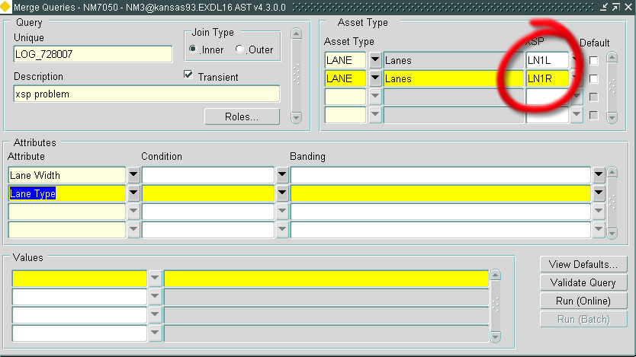  There is no way to restrict the XSP in the flexible attribute condition/criteria tab. Hence, if a user wishes to restrict by a combination of XSPs, the only way to achieve this is to configure two repeating asset types as shown above. However, the results over an area which has both assets (exclusive by XSP) will only contain one of the assets in a singular XSP.  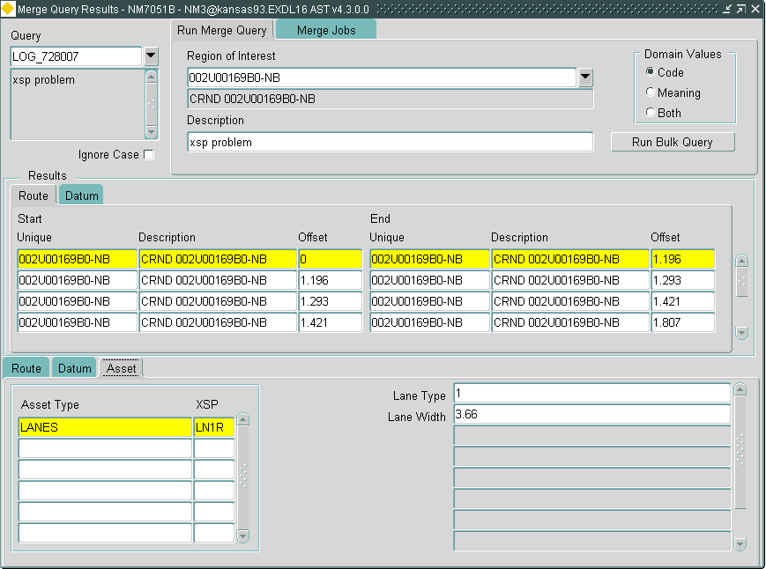  By re-ordering the xsps in the asset tab of the query tool, different results are obtained.  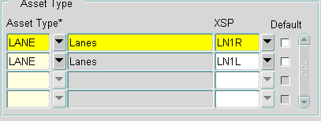  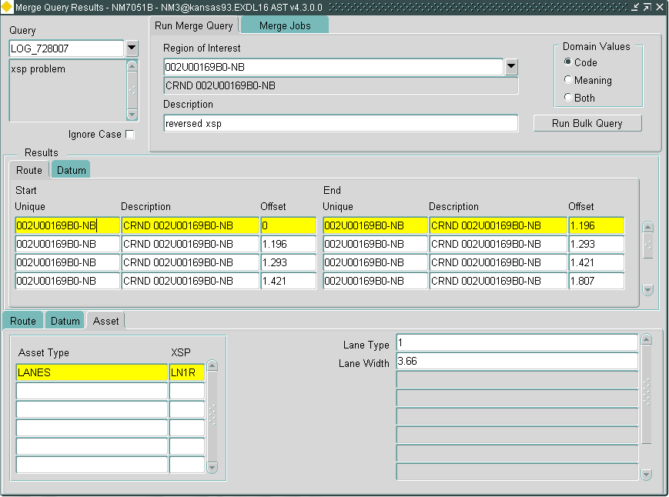  Execution of the old merge over the same route shows that the two assets are provided in the same section as desired:  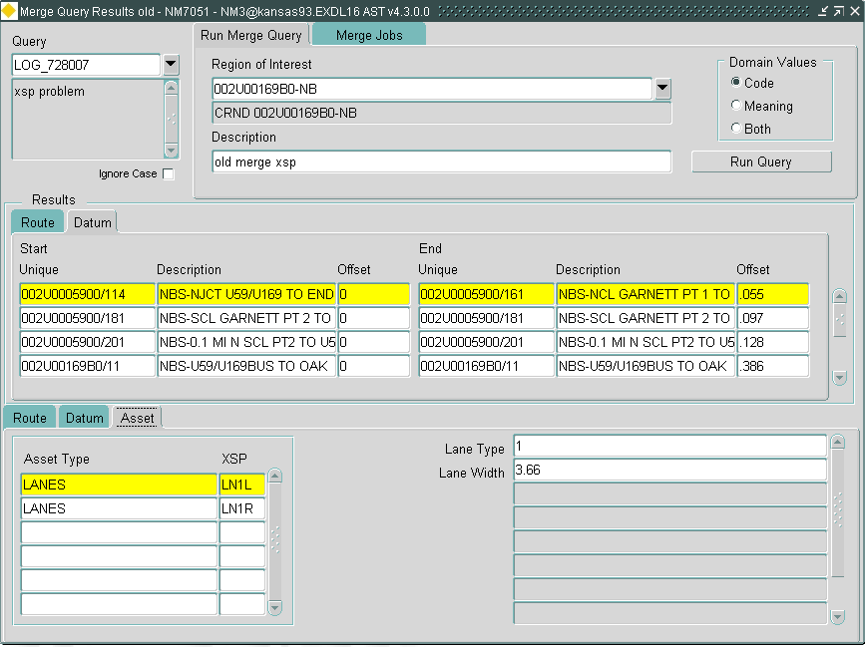 | 728007
 | A user has complained that a derived asset cannot be created due to the restricted number of column mappings. | 724833
 | If merge query cannot derive a linear reference for a chunk on a route due to the lack of meaningful measures due to the route never having been rescaled, it returns a measure of -1. Negative route offsets are allowed and this value should not be used as a means of reporting a problem. | 72771
0110281 | Failure of the merge result views indicating point data as a linear item due to the point being coincident with a node. Under these circumstances, the point source can be represented in two distinct merge sections which is then decoded by the view definition to indicate a linear item. | 728396

- Other issues known to remain at release 4.4.0.0
This list is composed of those issues are currently active in the sense that they are known and being worked on currently.

Internal  Task ID | Issue | Support  Log(s)
0111053 | On testing the execution of a simple PBI query, the system filed to deliver any results. After coding a test harness and executing the program manually through a network extent derived from a route, the server code failed with the message below.  ORA-20000: NET-0306: No network matches the filter criteria  ….  ORA-06512: at NM3PBI", line 110  ORA-06512: at line 5  The form looks to have executed the query in extremely quick time giving rise to suspicions that the execution has failed but that the error remains unreported. Further investigation will need to be performed.
0109654 | Engineering dynamic segmentation fails in cases where resultant section is not a route. The original code failed to account for the direction of a datum within the route – so functions such as first and last value were often incorrect on datums that were opposite to the cardinal route direction. The only method to correct this problem is to use the original route direction flags. It is this fix that causes failure when the NMS_OFFSET_NE_ID of a merge section is a datum due to no data being found.  In most systems, the number of occurrences is low. | 726192
0110998 | SM does not allow the date to be entered. The member dates are derived from the group start date (as opposed to the current date). The system should allow any date which is not less than the greater of the datum start date or the route start date. | 8001071424
0110997 | ASD date corrected in forms but not SM | 8001071423
0110840 | Number format error - rounding on large numbers in Spatial Manager
0109564 | Gazetteer Query fails (NET-0389) on specific route – due to Spatial manager adding trailing spaces on the NE_DESCR column. | 725606
0110438 | Error saving partial type 51, 52 & 53 recs in Spatial manager
0110458 | Ambiguous position not updated in split form of SM
0110837 | Zoom to groups of groups does not work in SM with NSG installed | 8001034167
0110797 | Type 64 tab - labels incorrect in Spatial Manager
0110796 | Query Layer error on a flexible attribute in a character column with a date format mask will fail in SM.
0109864 | Creation of an extent from a route layer in Spatial Manager fails | 711207
0111008 | Readonly forms are unavailable from menu | 8001075194
0111003 | Results tab missing on del. global asset | 8001071432
0111002 | Selected Categories Not Returned (del. global ast) | 8001071431
0111001 | Asset Location Start Date Wrong (after using delete global asset on part of asset location) | 8001071430
0111000 | Re-sequence does not prompt to save | 8001071428
0110999 | Undo does not undo route shape. From SM, the reshape of a datum may perform a surreptitious resequence of routes containing the datum. This produces a new route shape which is not refreshed if the datum reshape/replace is undone. The surreptitious re-sequence should not be performed by SM. | 8001071425
0110979 | lack of use of function lookups in derived assets | 725193
 | An Oracle bug (12536474) prevents the nm3sdo.validate_theme from working in the standard 11g mode when applied to LRS geometries on a 2d co-ordinate system – this procedure assumes all LRS layers have a dimension driven from the DIMINFO rather than the gtype of the geometries. The code in nm3sdo has been modified to be compliant with 10g, thus allowing successful completion but some invalid geometries will remain unreported. The validation of individual geometries remains consistent however and a workaround will be produced whereby the validation will apply to a bulk collection of geometries rather than the layer.

- ECDM Logs, Ticket numbers and test failures.
During the transition to use development tasks in the ECDM system, all ECDM logs with a priority of 1 to 3 were translated into tasks. There are around 120 logs of priority of 4 or 5 against version 4 releases that are outstanding that have not been converted to tasks. Most of these are against older releases. A further thirty or so relate to version 3 software. Many may have been picked up and assigned a task under a duplicated ECDM log or ticket number. There is little likelihood that these ECDM logs will be investigated unless they are re-raised.

The task system provides a list of work that may originate from customer tickets or ECDM logs as well as issues arising out of system test failures. These tasks pass through a process which assigns a status to each task. The various core products and task/status breakdown at the time of writing is as follows. The list contains all those tasks that originated before or during the 4.4 development cycle. A further 43 tasks have already been allocated to the release 4.5 development cycle.

Product | Status | Count

Map Capture | Design | 1
 | Assessment | 1
 | System test | 3
Asset Manager | Coding | 1
 | Assessment | 1
 | System test | 2
Spatial Server | Assessment | 1
 | System test | 2
 | Install Exor products | 1
Network Manager | Coding | 6
 | Assessment | 16
 | Code Review | 15
 | System test | 71
Spatial Manager | Design | 3
 | Assessment | 7
 | System test | 9
Map Capture Interface | Assessment | 2
 | System test | 9
Map Capture | Design | 1
 | Assessment | 1

